***Test Plan Artifact***

***Software Engineering I***

***CIS – 375***

***Professor: Kuimi Akingbehin***

***Due Date: August 15, 2018***

***Version 1.0***

***The Debuggers:***

***Marco Seman***

***Martin Zanaj***

***Jason Lu***

***Maricruz Zamora***

***Mohammed Altulz***

***Audrey White***

Test Plan

1. Three or four sentences describing the rapid prototype version of your project

The rapid prototype version of the project will primarily be used by the assistant. The customer calls to request service so the assistant logs into the system to process the request. Then the assistant selects from the main menu on which. prototype starts off with a login in screen in which the user must enter an access code. Once the user logs in, there is a menu screen. The menu allows the user to select new job, Job Task, Payment, Waiting List, Pending Request, Report, Tech Time Block, Notification, and Survey.

2. Five test cases including at least three

The test strategies we used were:

• black box testing

• unit testing

• boundary value testing

• bottom - up testing

|  |  |  |  |  |  |
| --- | --- | --- | --- | --- | --- |
| Test Number | Test Type | Input | Expected Output and/or Action | Actual Output and/or Action | Pass/Fail Decision |
| 1 | Black Box Testing | Button Event Handler. The user will select exit to return to the main menu | Every interface should have the ability to go back to the main menu screen7f | Working as expected | Pass |
| 2 | Boundary Testing | Zip Code  Name  Phone Number  State | Email Invalid (if no @ entered)  Does not allow user to enter more than 15 characters for name, no more than 5 for Zip code, and no more than 10 for phone number.  Error: Missing Input (for blank boxes) | No error message appears | Failed    Inserting image... |
| 3 | Bottom-Up Testing | Button Event Handler, and Login Access | Check and see if every function is accessible by first logging in, and then checking if all the button event handlers are working as anticipated. | Working as expected | Pass |
| 4 | Unit Testing | User login access code  mp000000 | (Attempting incorrect user login)  Authorization Fail! Try Again. | Working as expected | Pass |
| 5 | Unit Testing | User login access code  m0001 | The user is logged in | The main menu appears, giving the user the option | Pass |

1: Black Box Testing (All buttons go back to main menu, also **add a logout button**) Show Screenshots

Result After Logging in:

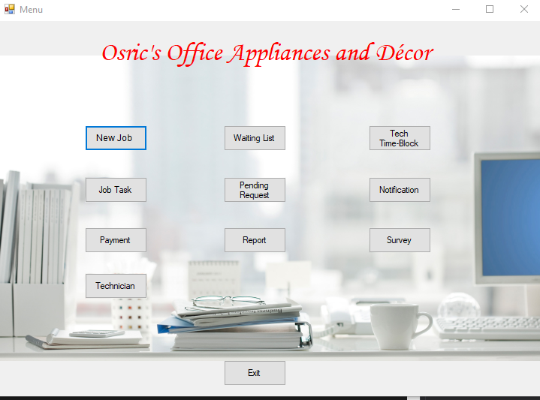

New Task:

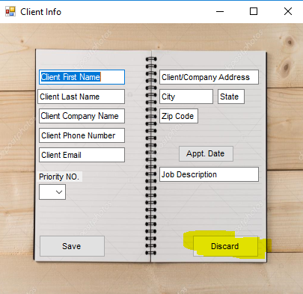

Waiting List:

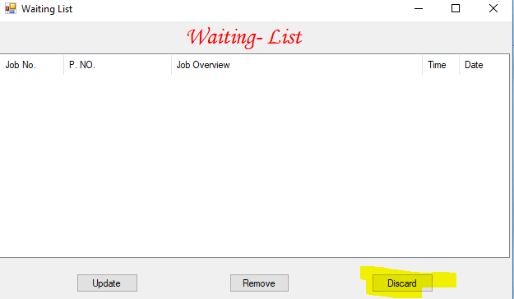

Tech Time-Block:

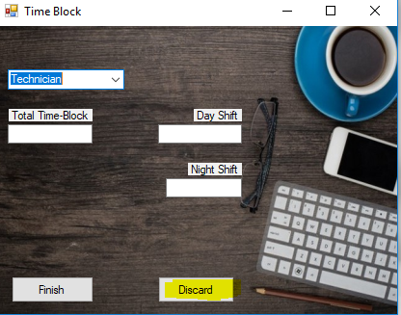

Job List:

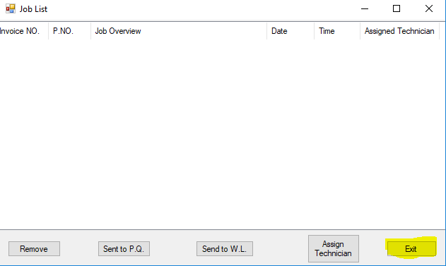

Manager Approval:

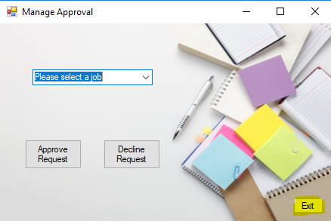

Notification:

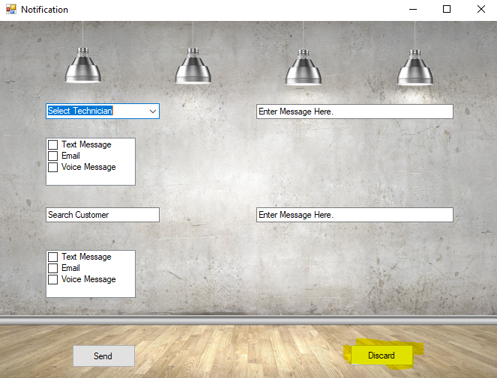

Payment:

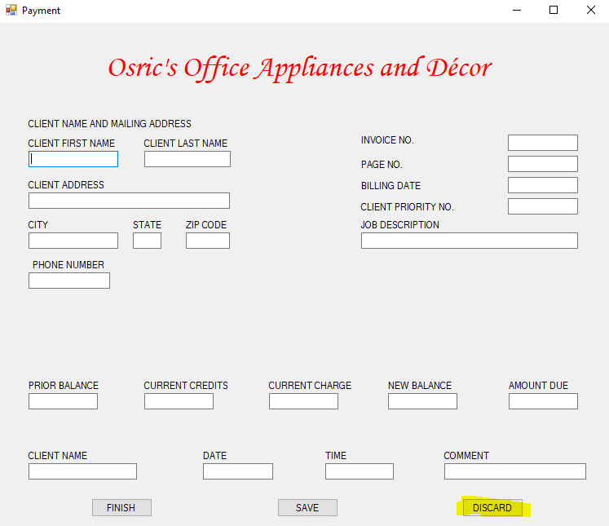Technician Info:

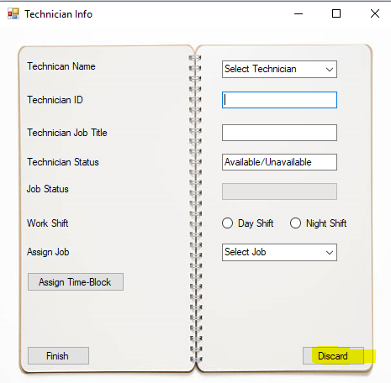

2: Boundry Testing (Zip Code, Name, Phone Number, State) **Show Screenshots Here:**

**Blank Input:**

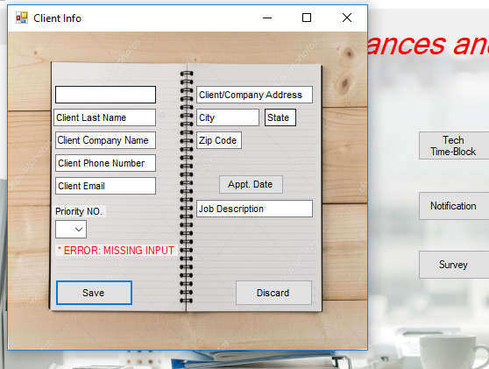

3: Bottom-Up Testing (Testing Every Function)

New Job Appt Date and Save Button

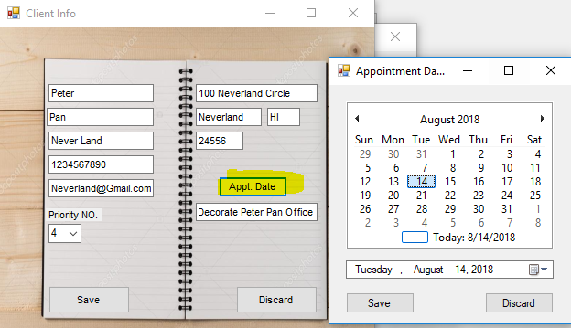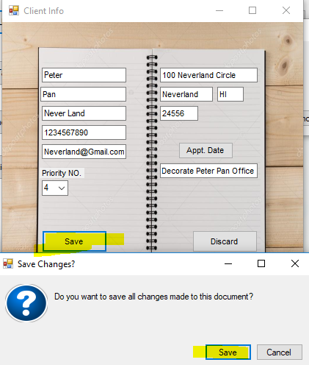

Payment Save Button

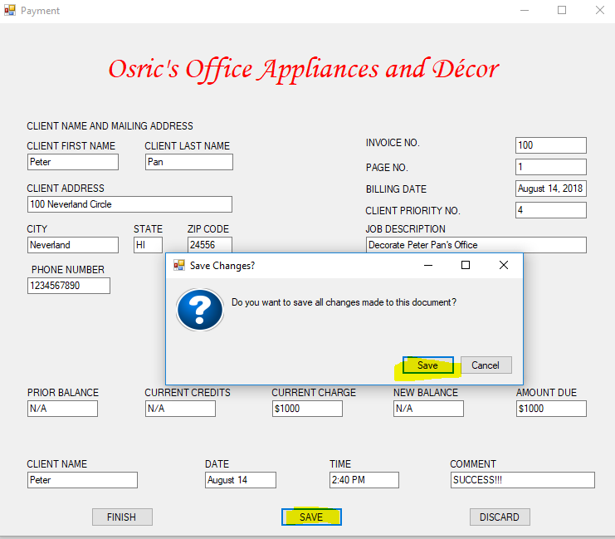

Send Survey:

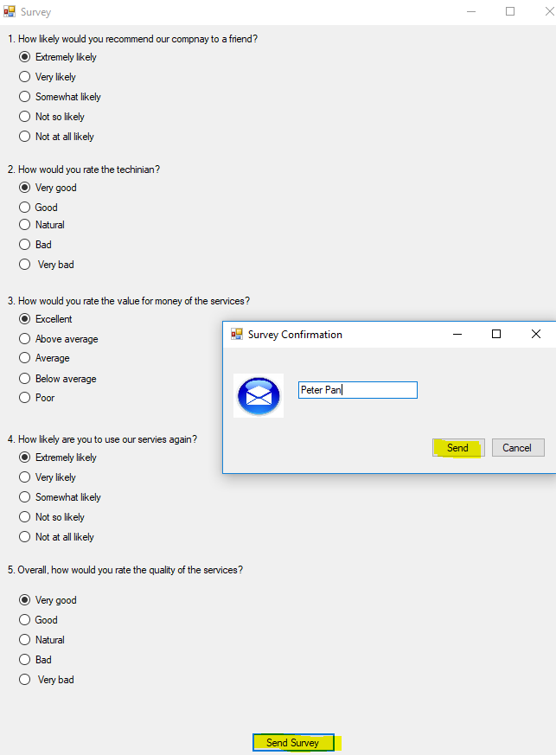Technician Info:

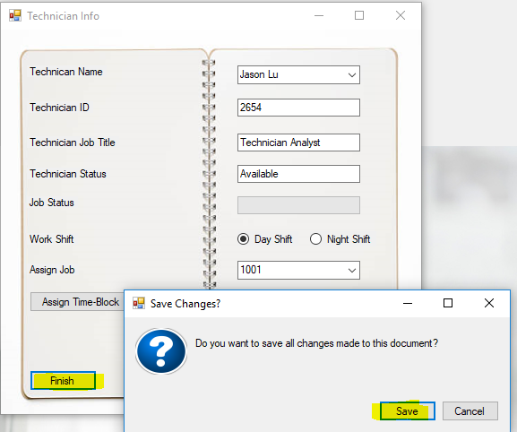

Exit Application:

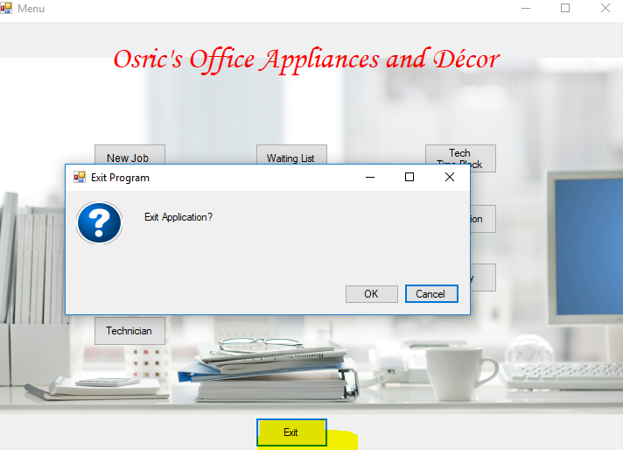

4: Unit Testing (Incorrect User Access Code)

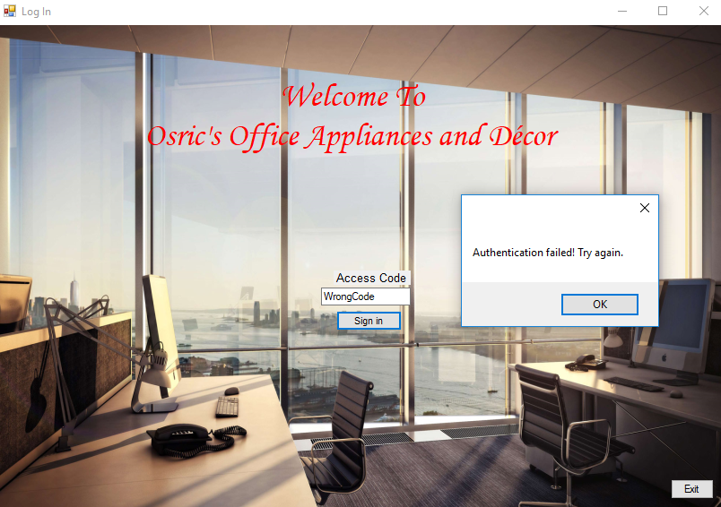

5: User Logs in

